**Comet Crawler Web Search Engine System Design Specification: Phase 1**

**Team 1:**

**Areebah Fatima**

**Tyler Hargreaves  
Darrien Kramer**

**Ilhaam Syed**

**Nathan Heindl   
Matthew Bedford**

Note: This Project Plan is out of date. Please see the Final Project Plan for a more accurate version.

TABLE OF CONTENTS

1. INTRODUCTION 3
   1. Purpose 3
   2. Scope 3
   3. Assumptions 3
   4. Project Unified Process (UP) / Road Map 4

1. REQUIREMENT SPECIFICATIONS 5
   1. Functional Requirements 5
   2. Non-Functional Requirements 6
2. USE CASE DIAGRAMS 7
3. SEQUENCE DIAGRAMS 8
4. CLASS DIAGRAMS 17
5. ADDITIONAL POINTS 22
   1. List of additional points and links 22

**1. INTRODUCTION:**

* 1. **PURPOSE**

The project's end goal is to create a system that will provide users with relevant information using the keywords entered by the user. The resulting data will be a sorted and filtered list of web page URLs to the end user. The major components of the search engine will include a search interface, indexing system, result filtering, query processing, etc. The search interface will allow the end user to interact with the system, enter search queries, and retrieve information. The indexing system will organize, store, and rank information to allow for a reasonably fast search. Result filtering will ensure that our system provides users with relevant, up-to-date data in sorted order. Finally, the query processing component of the project will be responsible for interpreting user inputs, identifying keywords in said input, performing index lookup, and retrieving results.

This document is the final project report. This document aims to explain our project's Unified Process and highlight all significant project changes. It includes Use Case Diagrams, Sequence Diagrams, and Class Diagrams for our Comet Crawler Web Search Engine.

* 1. **SCOPE**

* This project strictly focuses on the Comet Crawler Search engine and its additional functions.
* The system comprises a search engine including a search interface, indexing system, result filtering, query processing, etc.
* The system does not have privileges for specific functionalities. Therefore, search users can perform searches, add URL entries, modify the index, delete URL entries, and manage system settings.
* The system allows multiple users to search at the same time.
  1. **ASSUMPTIONS**

The following assumptions constrain the Comet Crawler Search Engine:

* Because we are implementing a long-term-support version of Ruby on Rails, we will be operating under the presumption that HTTP dispatching, database access, and other core functionality is handled appropriately. This design philosophy allows us to consider engineering the search algorithm and other important application-specific features.
* The application is dependent on Rails and its dependencies. A complete list of requirements can be found at: [**https://github.com/tyharg/CS-4376/blob/main/Gemfile**](https://github.com/tyharg/CS-4376/blob/main/Gemfile).
  1. **PROJECT UNIFIED PROCESS (UP) / ROAD MAP:**

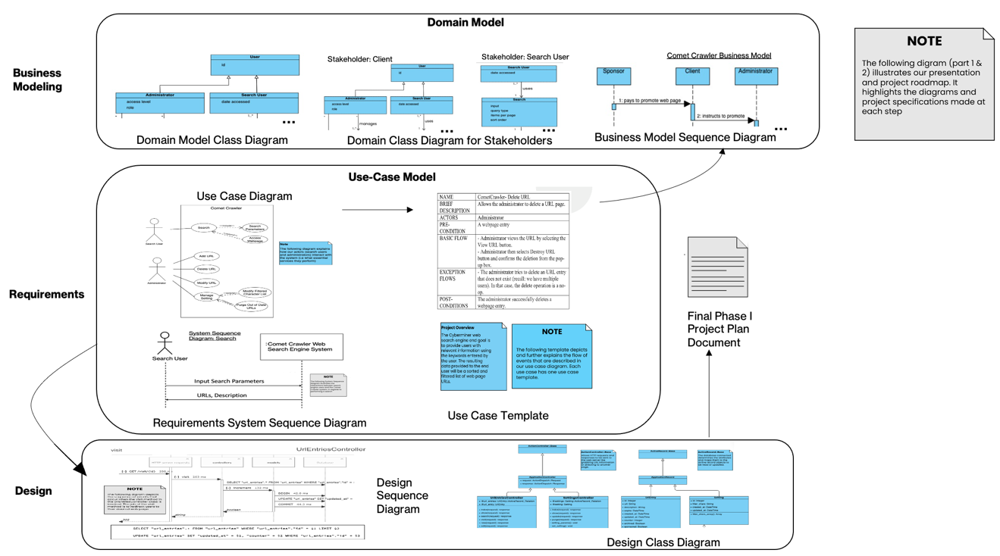

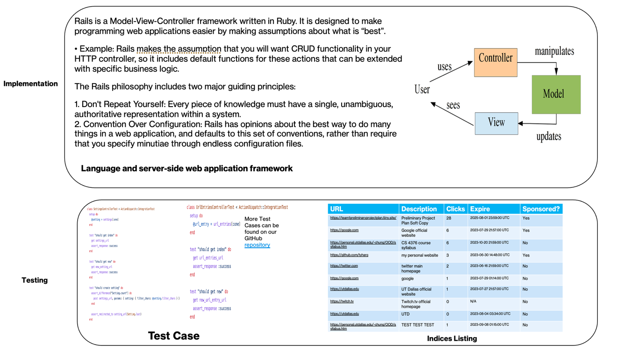

1. **REQUIREMENT SPECIFICATIONS:**
   1. **FUNCTIONAL REQUIREMENTS:**

1F. **Case-sensitive Search:** The system shall store and retrieve the input exactly as provided, preserving case sensitivity.

2F. **Hyperlink enforcement:** When a user clicks on a URL obtained from a query result, the system shall redirect the user to the corresponding website.

3F. **Specifying OR/AND/NOT Search:** The system shall allow users to specify the search mode (OR, AND, or NOT) for keyword-based searches.

4F. **Multiple search engines:** The system shall support the concurrent execution of multiple search engines.

5F. **Purging of out-of-date URLs and descriptions: The** system shall provide functionality to delete outdated URLs and their corresponding descriptions from the database.

6F. **Query result listing options:** The system shall offer the ability to list query results in ascending alphabetical order, most frequently accessed order, or based on payment preferences.

7F. **Customizable result display and navigation:** The system shall allow users to set the number of results displayed per page and provide navigation functionality between pages.

8F. **Autofill with error correction:** The system shall automatically provide autofill suggestions while correcting typographical errors.

9F. **Symbol filtering based on user configuration:** The system shall filter out symbols that are not considered meaningful, according to user-configured settings.

10F. **Sponsored Web Entries with Priority Display:** The system shall allow web entries to be designated as sponsored if an advertiser has made a payment for promotional purposes. Sponsored URLs shall be given priority in the display of query results, ensuring they are shown prominently before non-sponsored entries.

11F. **Search Query Result List:** The system shall provide users with the ability to input a search query, and upon submission, generate and display a list of URL entries as the output, based on the search query.

12F. **Parsing and Filtering of User Input Queries:** The system shall parse user input queries to extract relevant keywords while ignoring specified filter characters. The extracted keywords shall be utilized to generate the resulting output list of URL entries.

13F. **URL Entry Management:** The system shall provide specific users with the ability to add, modify, delete, and promote URL entries. These privileged users shall have the necessary access and permissions to perform these actions on the URL entries within the system. This privileged user functionality must be implemented during the second iteration of the project.

* 1. **NON-FUNCTIONAL REQUIREMENTS:**

1N. **Performance:** The Comet Crawler system shall provide fast and efficient search results, ensuring minimal response times even when handling many concurrent user requests.

2N. **Compatibility and Portability:** The Comet Crawler system shall be compatible with commonly used web browsers, ensuring proper functionality and consistent user experience across different browser versions. It should adhere to web standards and compatibility guidelines.

3N. **Usability:** The Comet Crawler system shall have a user-friendly interface, providing a seamless and intuitive search experience for users. It should be accessible across different devices and platforms.

4N. **Error-Handling:** The Comet Crawler system shall implement comprehensive error handling mechanisms to handle exceptions and provide informative error messages to users.

5N. **Reliability:** The Comet Crawler shall be highly reliable, providing consistent and uninterrupted search functionality to users. It should minimize system failures and errors, ensuring reliable access to search capabilities and delivering accurate results.

1. **USE CASE DIAGRAMS:**

Definition: A use case diagram models the observable behaviors of a system from an actor/user’s perspective. This allows us to communicate essential services and the scope of the system. The main goal of this diagram is to help people understand the system and aid in achieving the client’s primary goals.

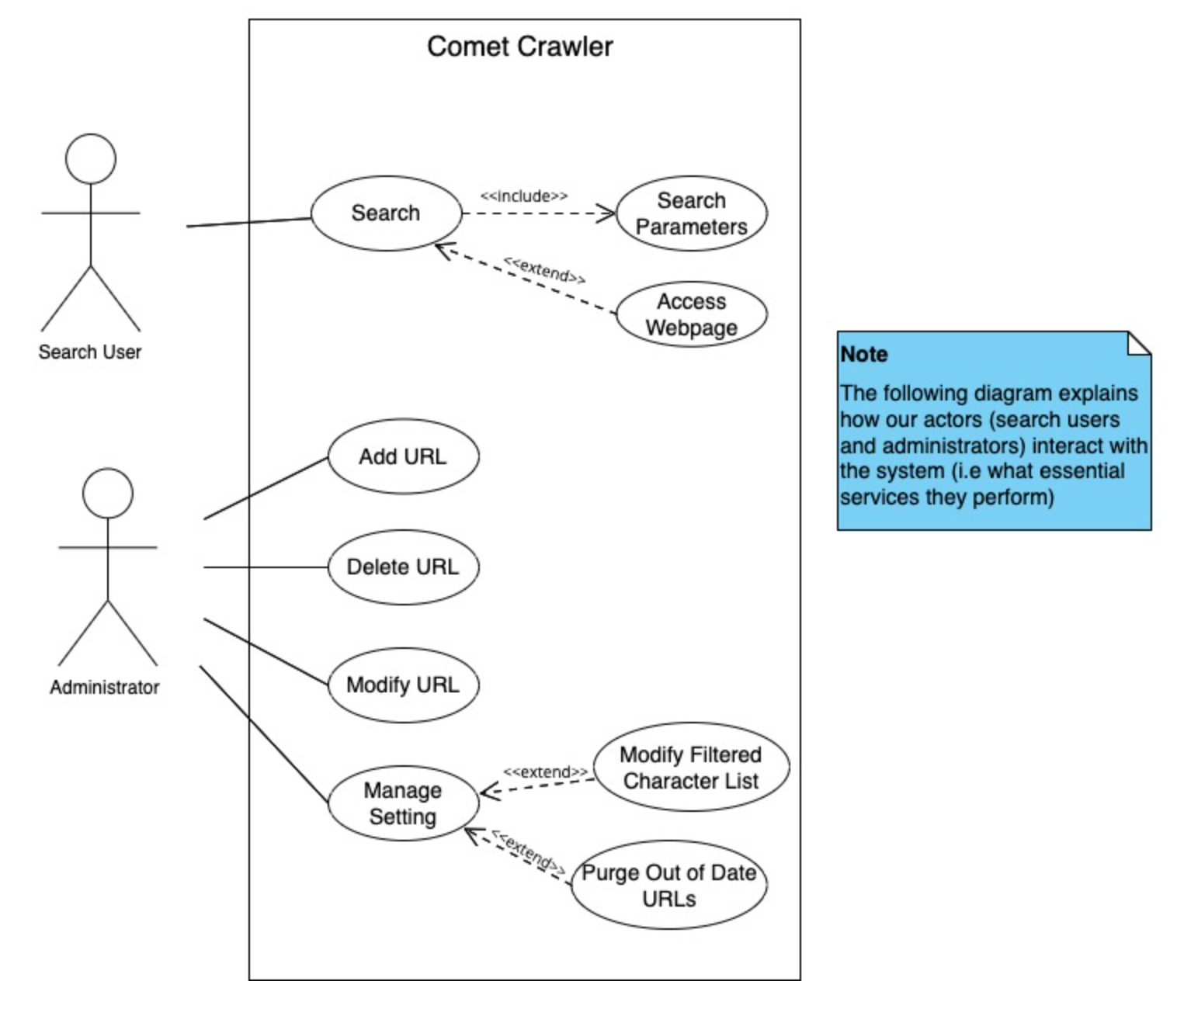

Figure 3.1 Comet Crawler Web Search Engine System Use case diagram (Part of Requirements)

DESCRIPTION:

The Search User actors will enter search parameters to perform a search and have the option to click a URL from their search results list to redirect themselves to a different webpage. Administrator actors will add URLs, delete URLs, modify URLs, and manage system settings. It is assumed they have logged in before performing any such activities.

Associated Use Case Templates:

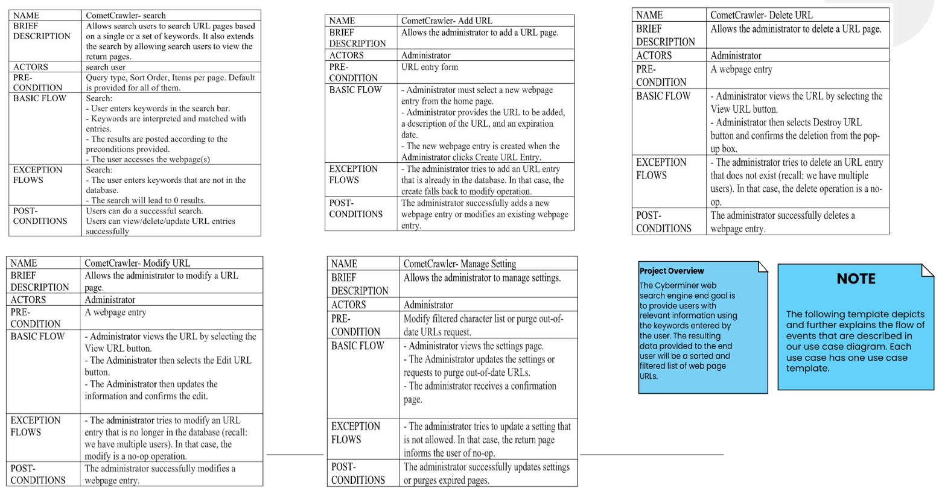

1. **SEQUENCE DIAGRAMS:**

Definition: A sequence diagram models the sequence of interactions (as time flows downward) to help understand and communicate how various system components cooperate to bring a use case functionality into fruition.

**BUSINESS MODEL SEQUENCE DIAGRAMS:**

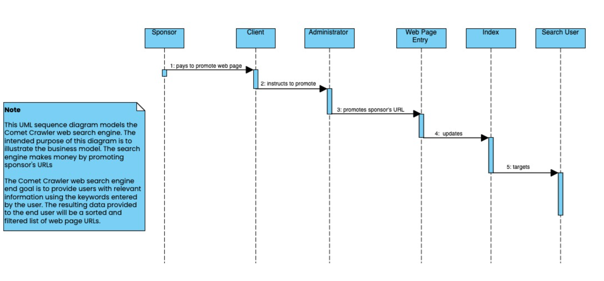

Figure 4.1 Sequence Diagram to Model the Comet Crawler Web Search Engine’s Business Model

**SYSTEM SEQUENCE DIAGRAMS:**

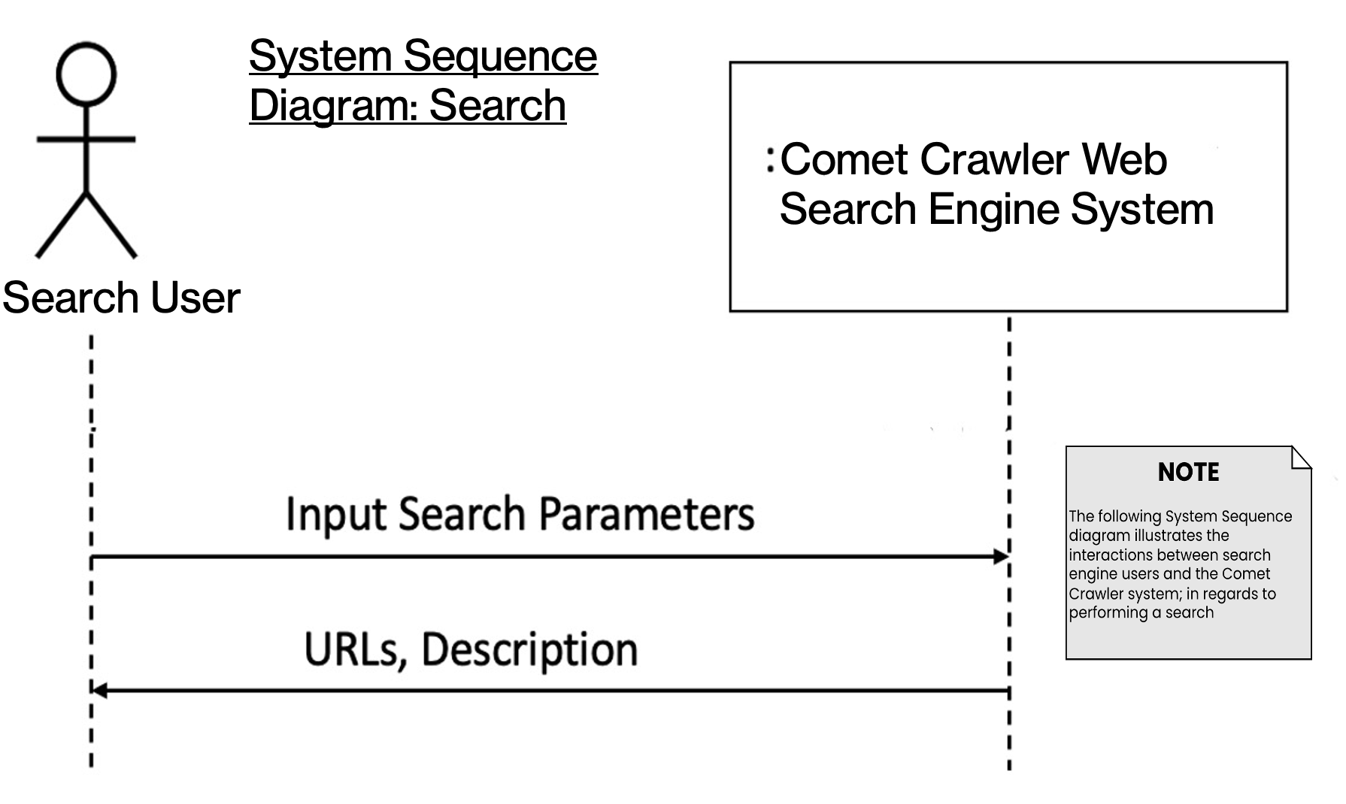

Figure 4.2 Comet Crawler Web Search Engine System Sequence Diagram for Search

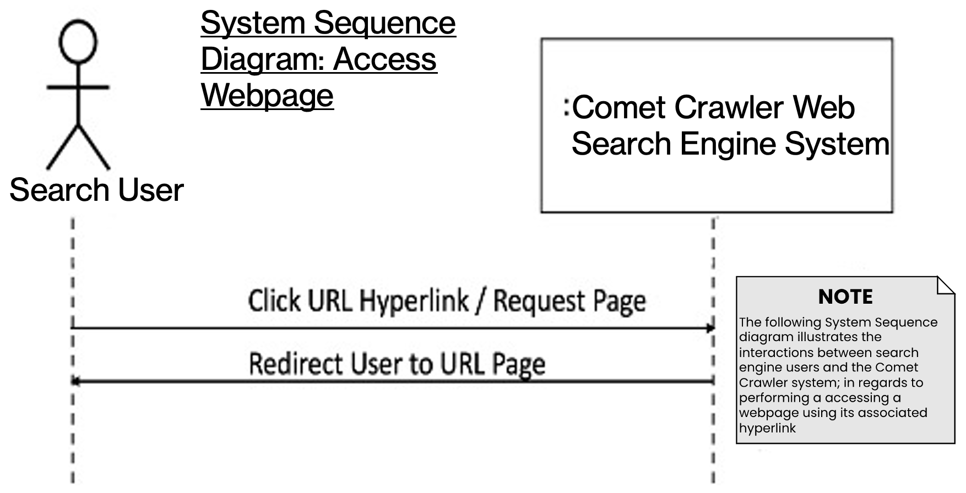

Figure 4.3 Comet Crawler Web Search Engine System Sequence Diagram for Accessing Webpages

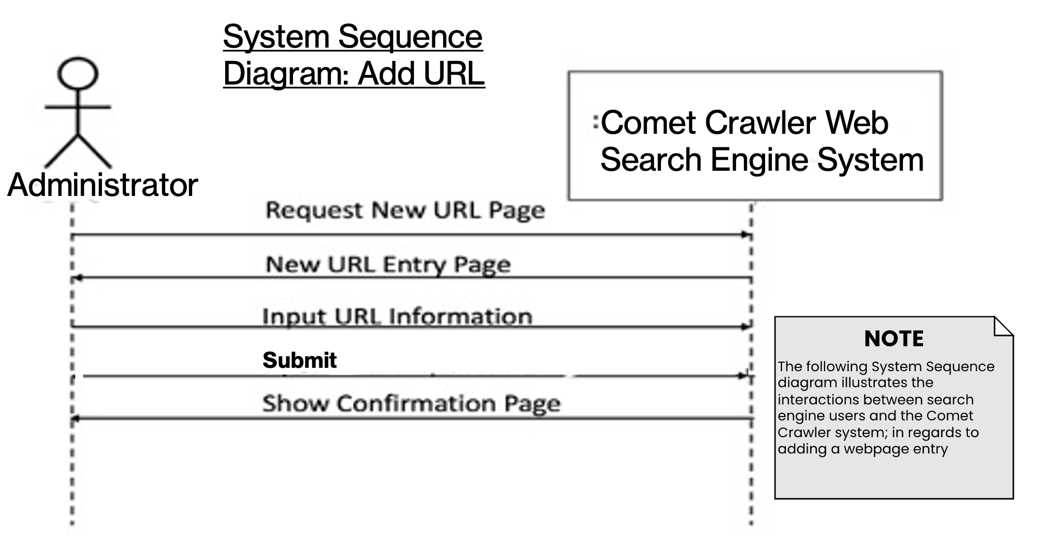

Figure 4.4 Comet Crawler Web Search Engine System Sequence Diagram for Adding URLs

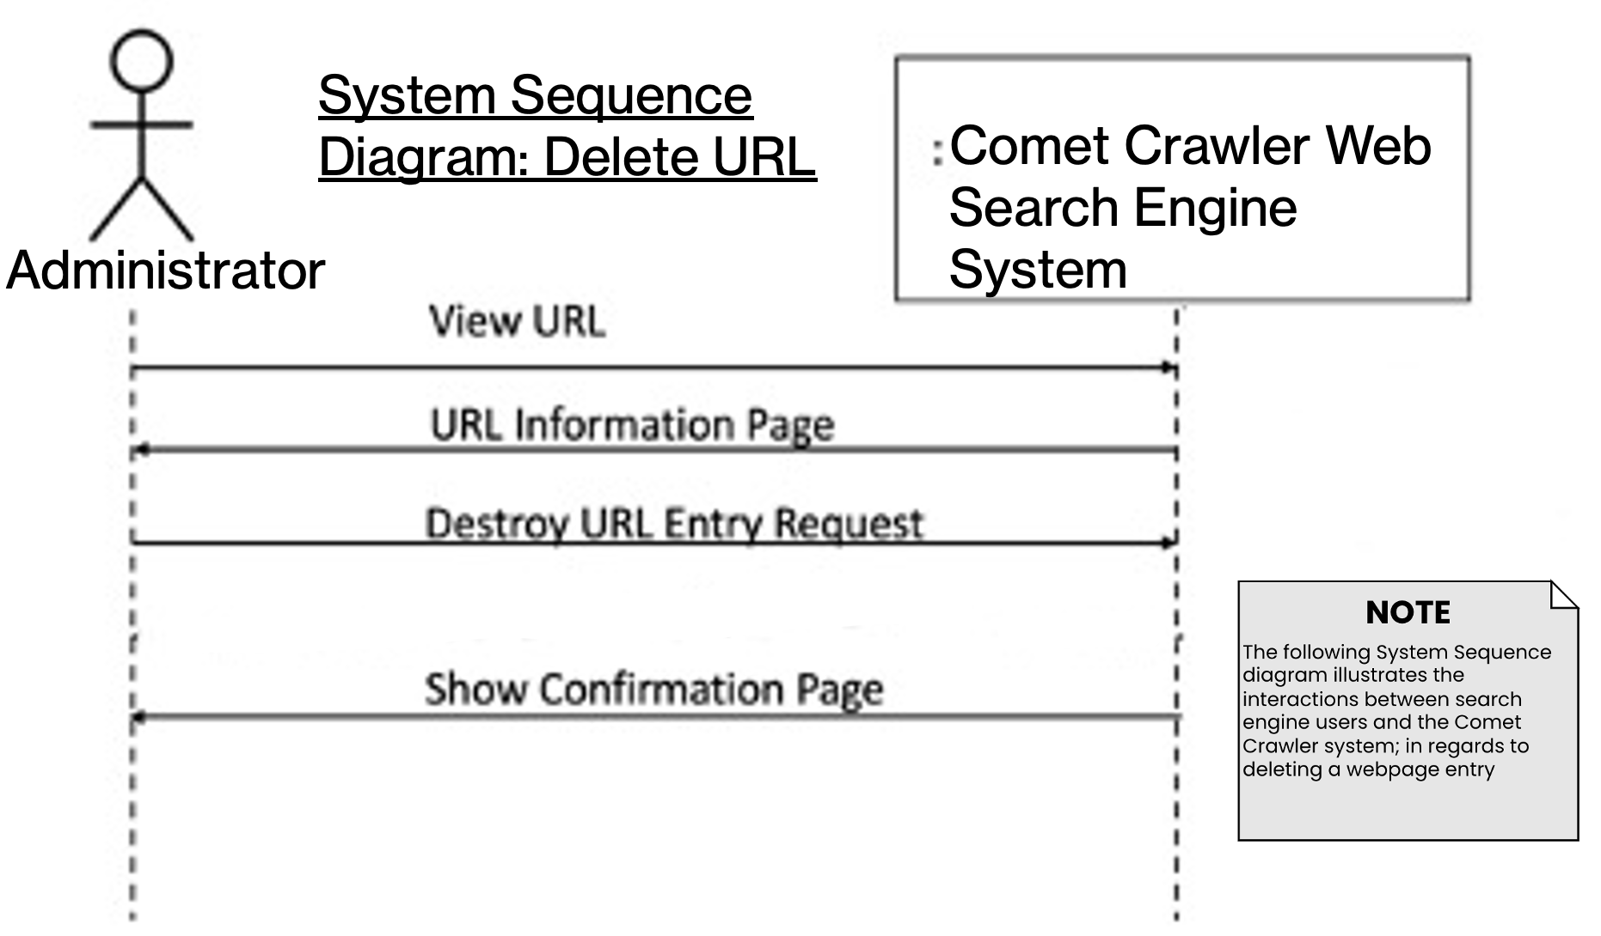

Figure 4.5 Comet Crawler Web Search Engine System Sequence Diagram for Deleting URLs

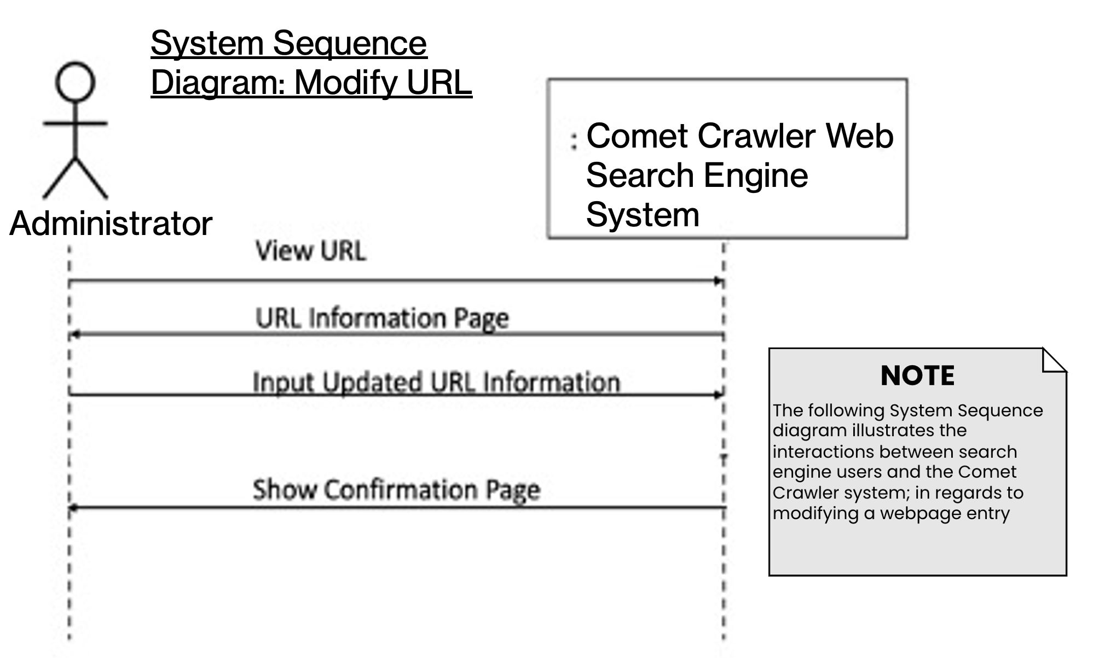

Figure 4.6 Comet Crawler Web Search Engine System Sequence Diagram for Modifying URLs

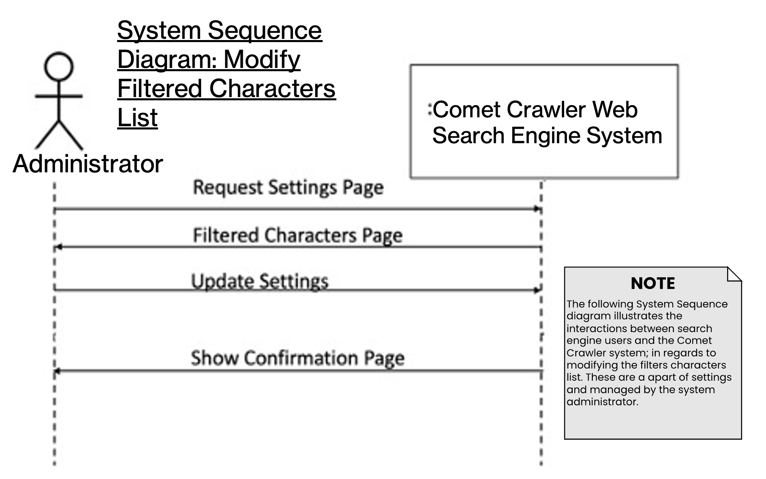

Figure 4.7 Comet Crawler Web Search Engine System Sequence Diagram for Modifying the System Setting’s Filtered Characters List

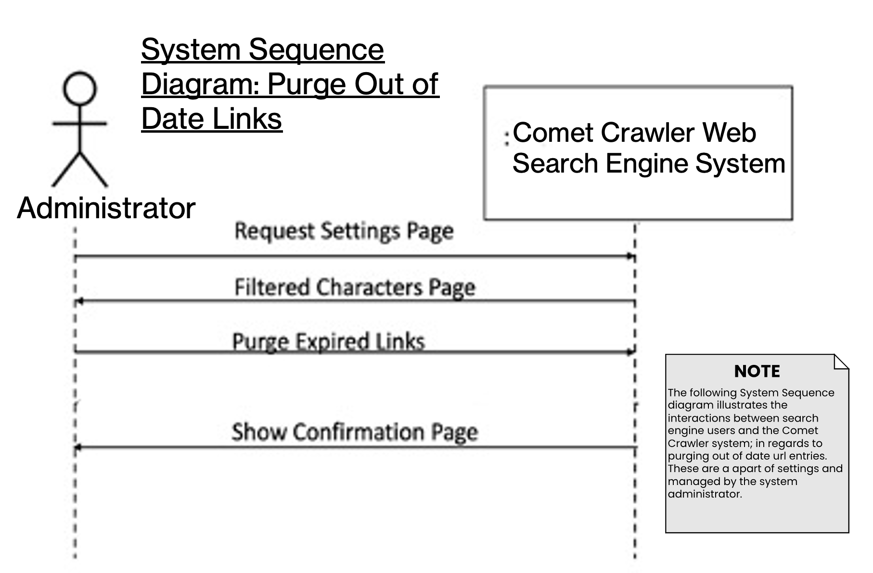

Figure 4.8 Comet Crawler Web Search Engine System Sequence Diagram for Purging Out-of-Date URLs

**DESIGN SEQUENCE DIAGRAM:**

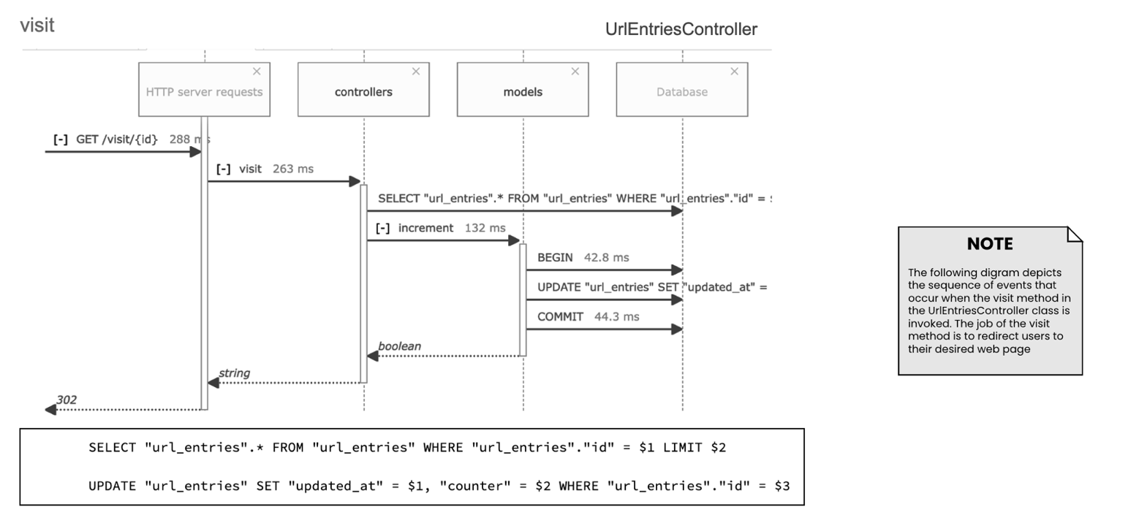

Figure 4.9 Comet Crawler Web Search Engine Sequence diagram for visit function

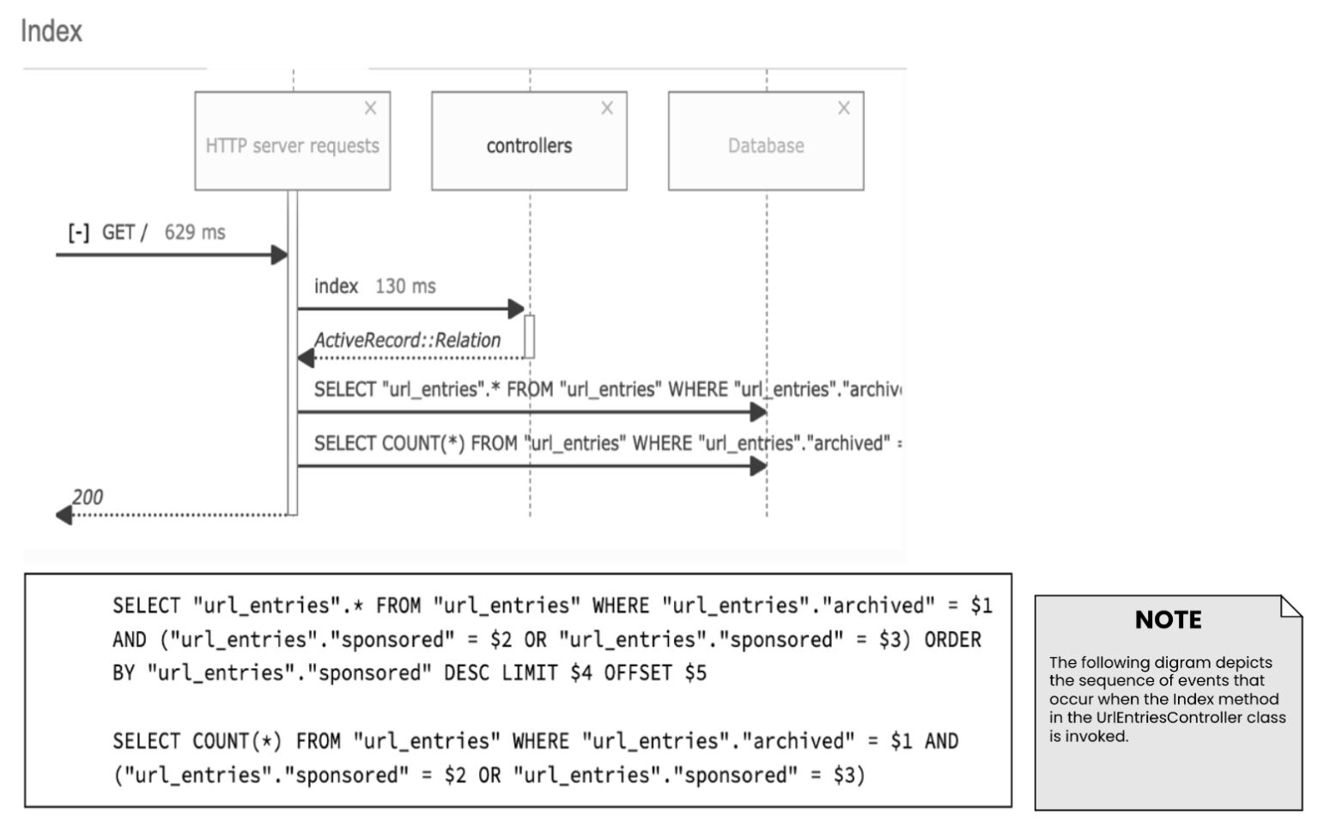

Figure 4.10 Comet Crawler Web Search Engine Sequence diagram for the System’s Index (Part of UrlEntriesController)

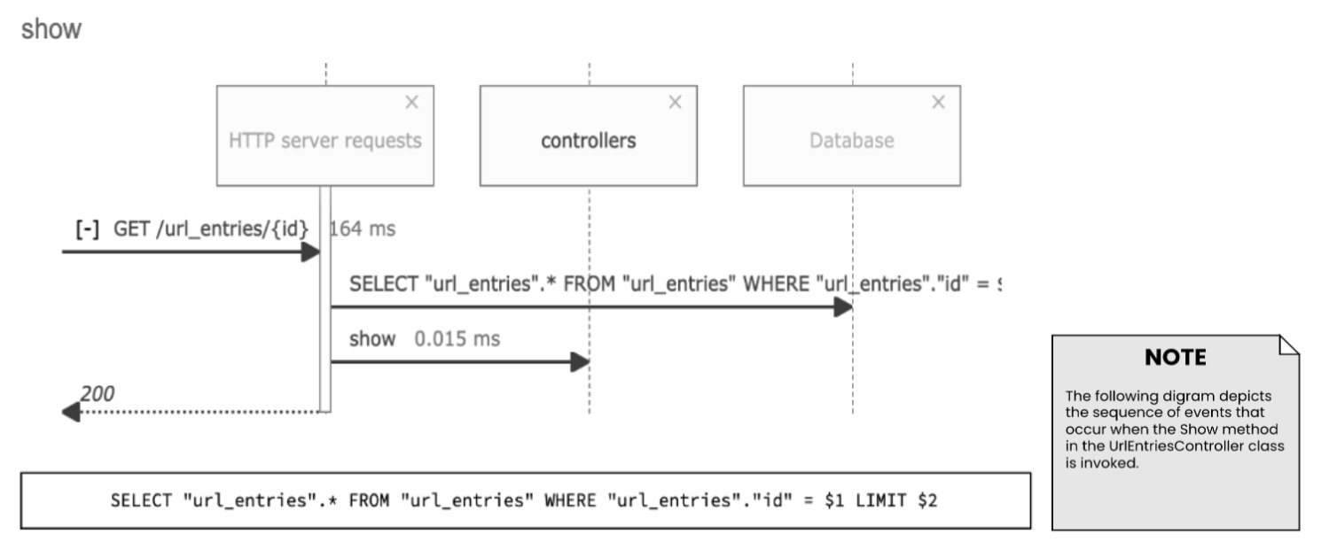

Figure 4.11 Comet Crawler Web Search Engine Sequence diagram for the show function. (Part of UrlEntriesController)

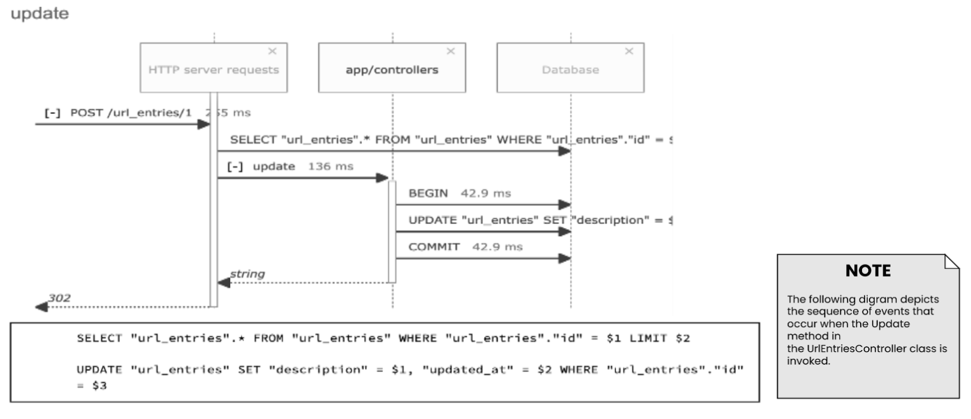

Figure 4.12 Comet Crawler Web Search Engine Sequence diagram for the update function. (Part of UrlEntriesController)

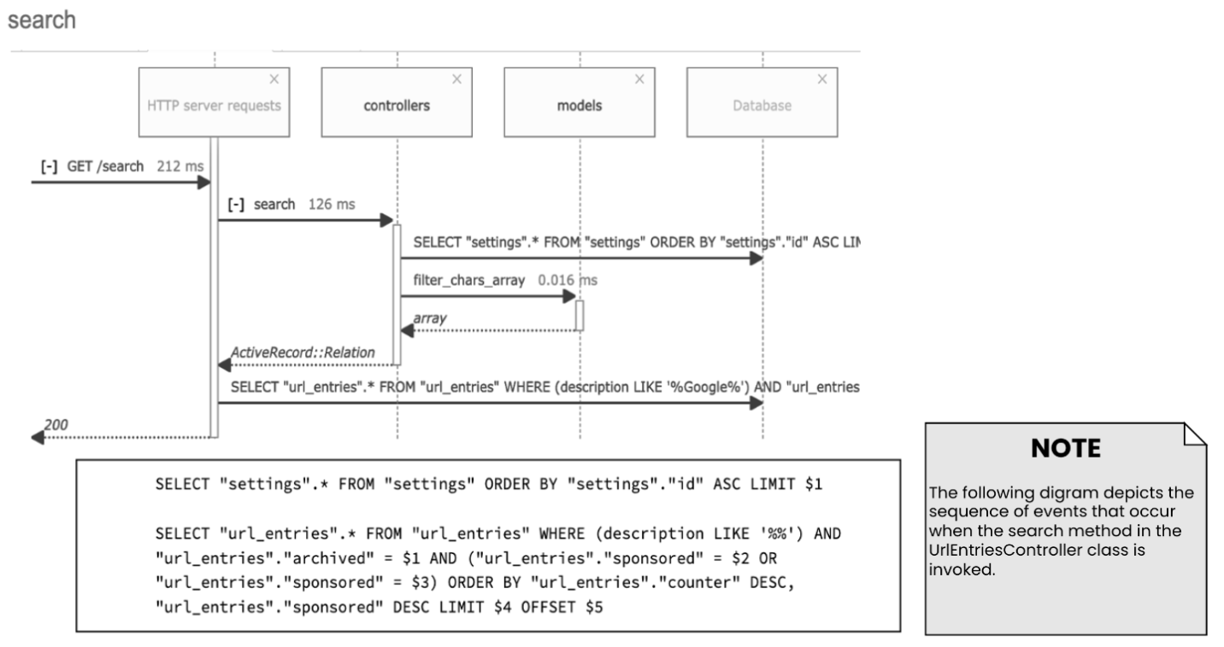

Figure 4.13 Comet Crawler Web Search Engine Sequence diagram for the search function. (Part of UrlEntriesController)

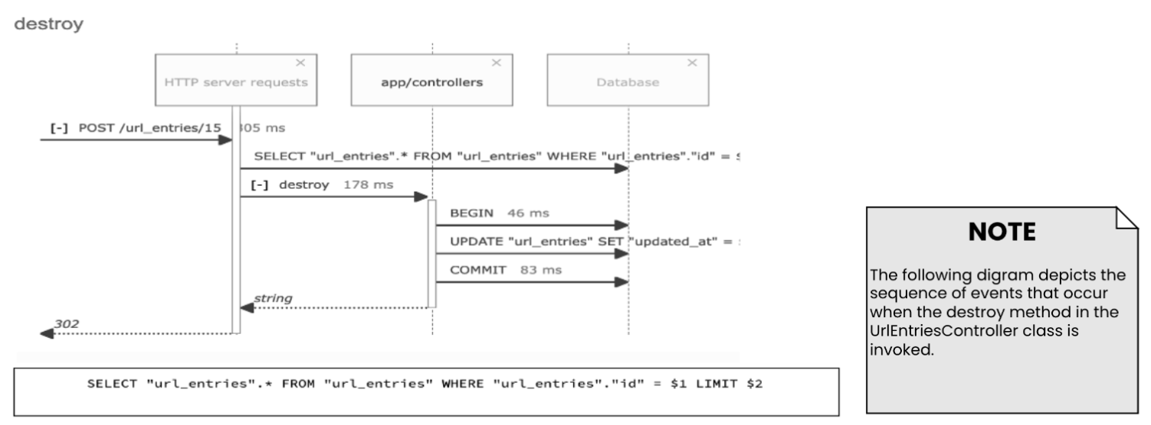

Figure 4.14 Comet Crawler Web Search Engine Sequence diagram for the destroy function. (Part of UrlEntriesController)

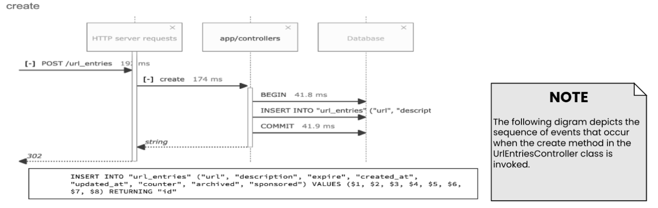

Figure 4.15 Comet Crawler Web Search Engine Sequence diagram for the create function. (Part of UrlEntriesController)

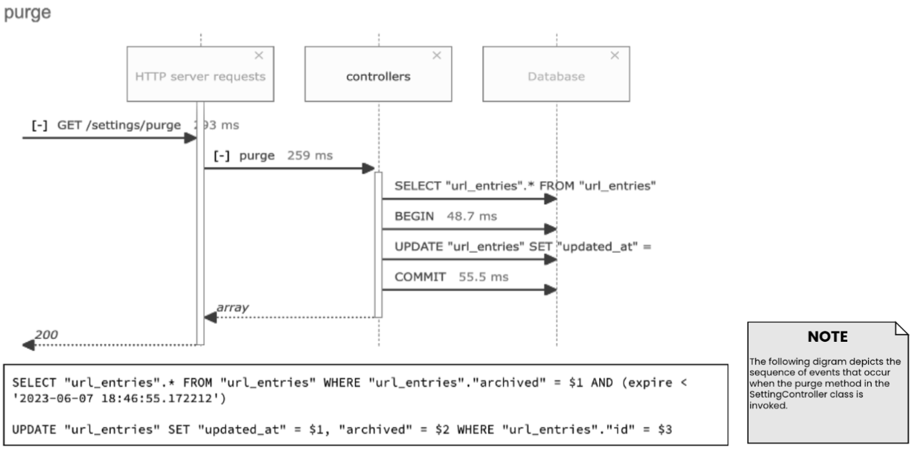

Figure 4.16 Comet Crawler Web Search Engine Sequence diagram for the purging expired links function. (Part of SettingController)

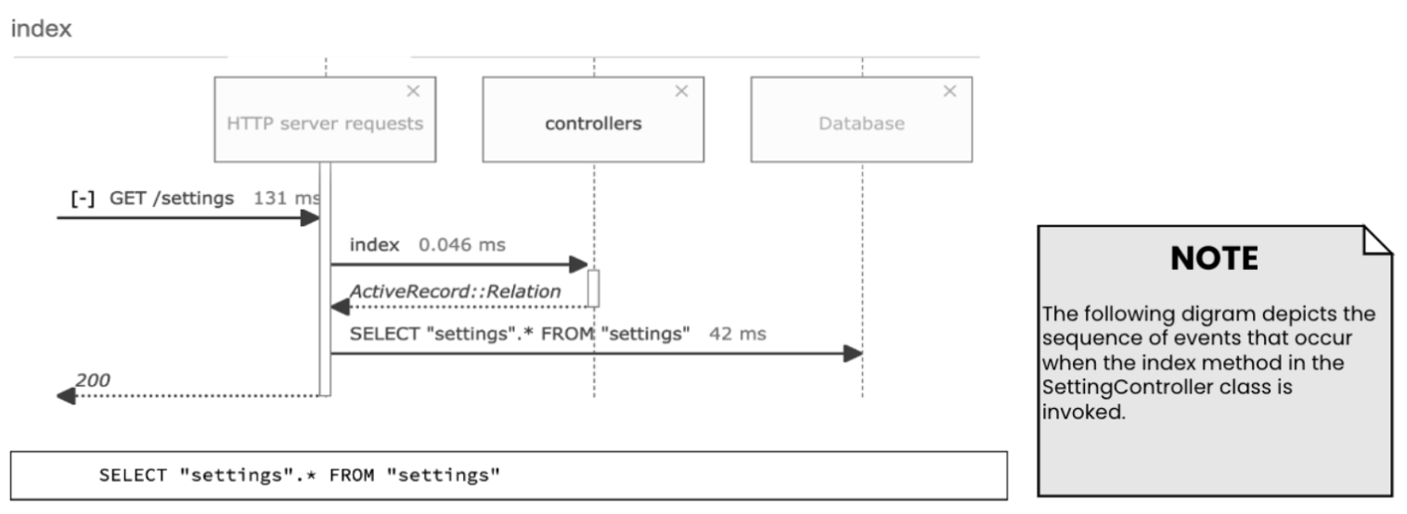

Figure 4.17 Comet Crawler Web Search Engine Sequence diagram for the Setting’s Index. (Part of SettingController)

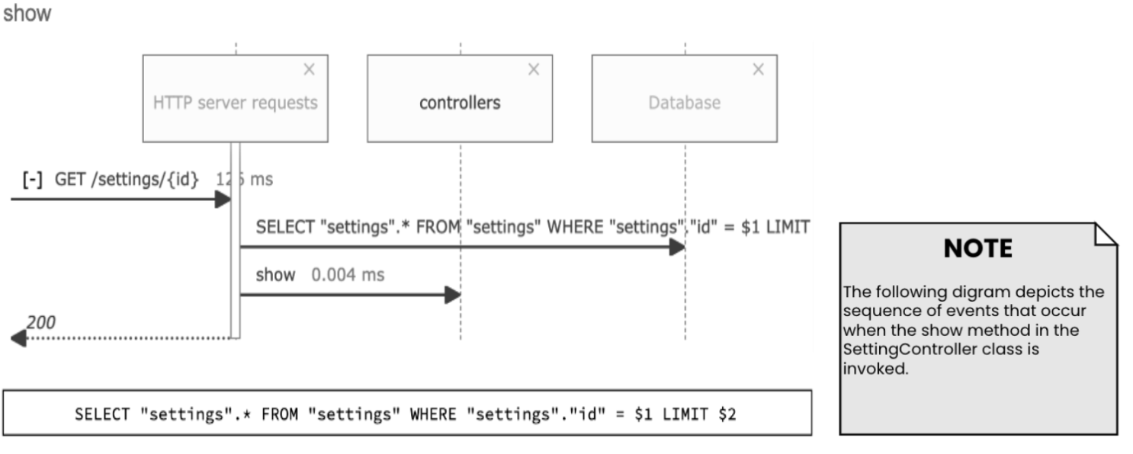

Figure 4.18 Comet Crawler Web Search Engine Sequence diagram for the show settings function. (Part of SettingController)

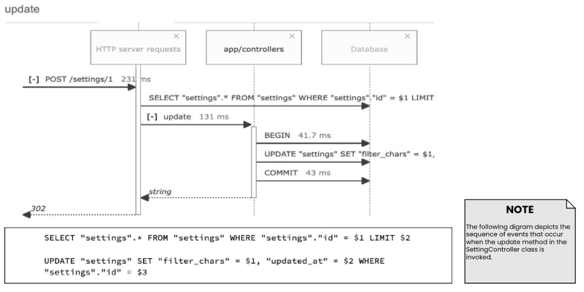

Figure 4.19 Comet Crawler Web Search Engine Sequence diagram for the update settings function. (Part of SettingController)

1. **CLASS DIAGRAMS:**

Definition: A class diagram provides a static view of the system’s structure. It highlights key concepts from the problem and solution domain to better understand the structure of classes and how they interact. A class diagram shows classes, class attributes, class methods, and relationships between classes.

**Class Diagram for Domain Model:**

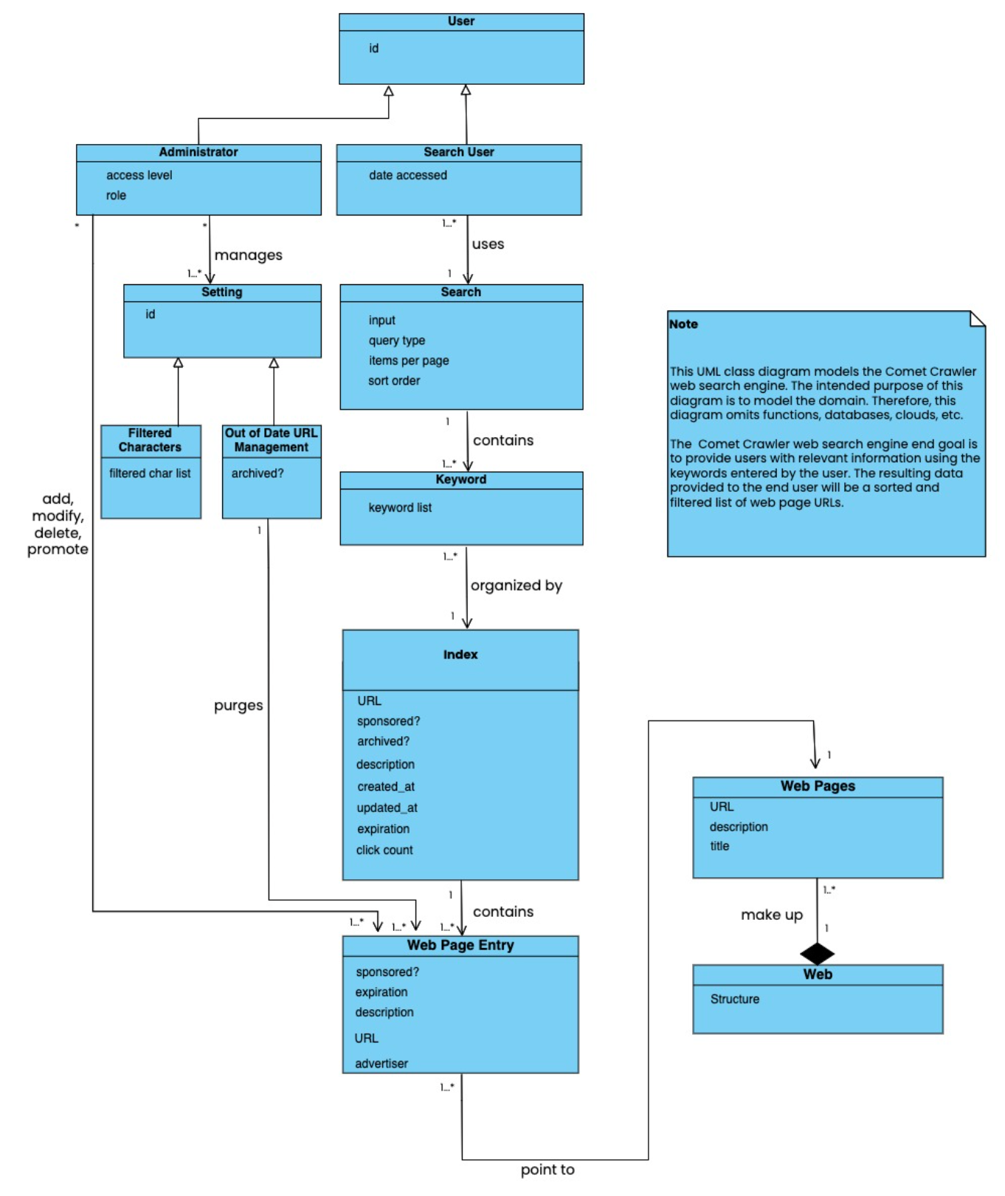

Figure 5.1 Comet Crawler Web Search Engine System Class Diagram

Comet Crawler Stakeholders:

* **Administrator:** Are privileged users with the ability to add, delete, and modify URL entries. In addition to this, they also manage the system filtering and purging settings.
* **Client:** Are the ultimate owner of the project. This ownership allows them to specify project requirements, making them the recipients of project deliverables and the resulting product.
* **Sponsor:** Are the individuals that pay money to promote their websites to the top of the search result list. Stakeholders are the central piece of the business model as they bring monetary incentives for clients.
* **Search Users:** Are the individuals who interact with the Comet Crawler System. They will provide the search parameters and view the associated results. Sponsors will target these users.

**Class Diagrams Based on Stakeholder Views:**

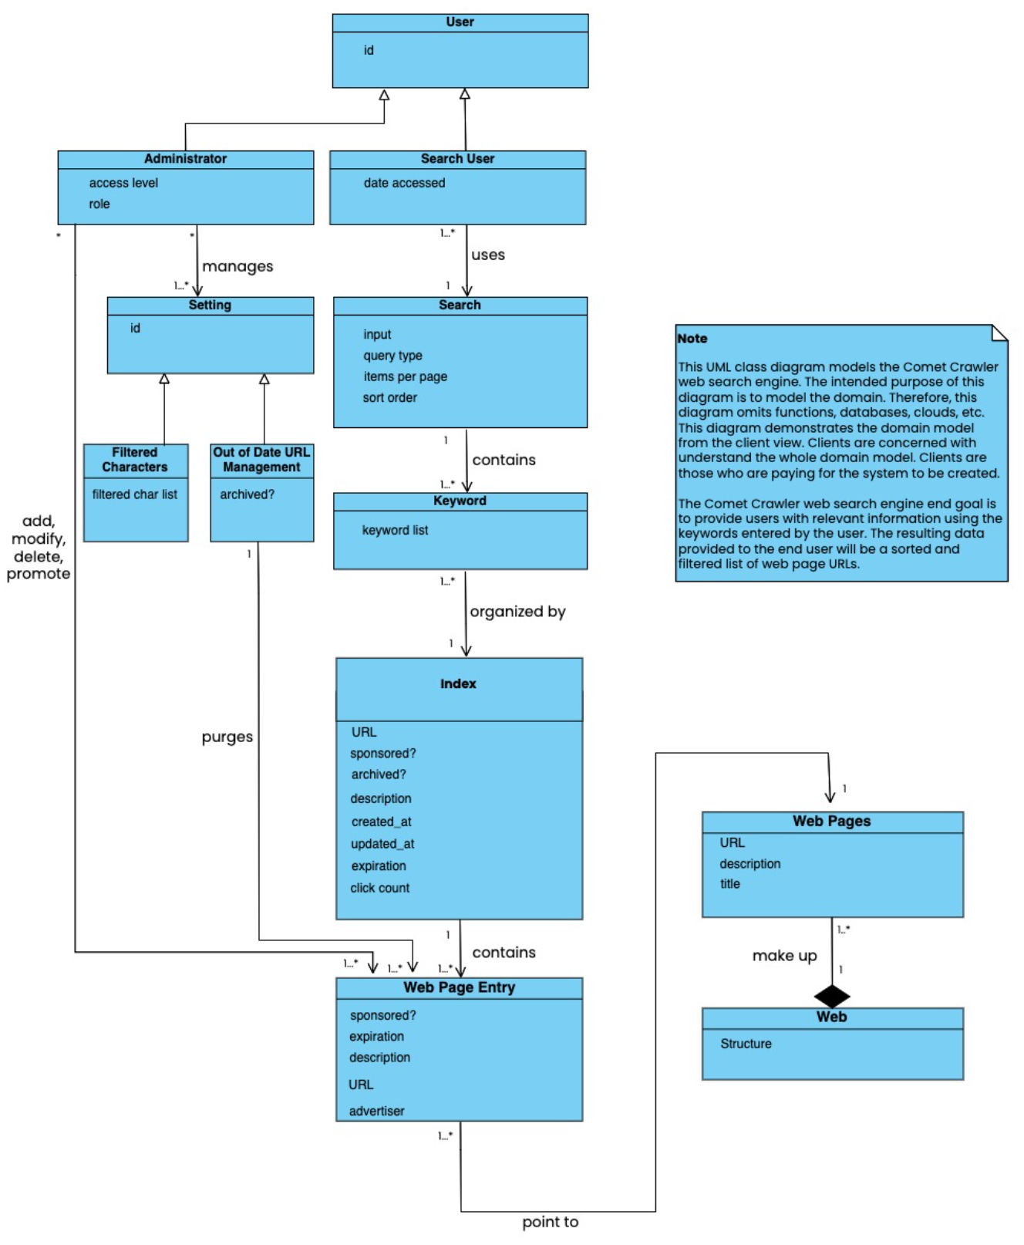

Figure 5.2 Comet Crawler Web Search Engine System Class Diagram (Based on Client’s View)

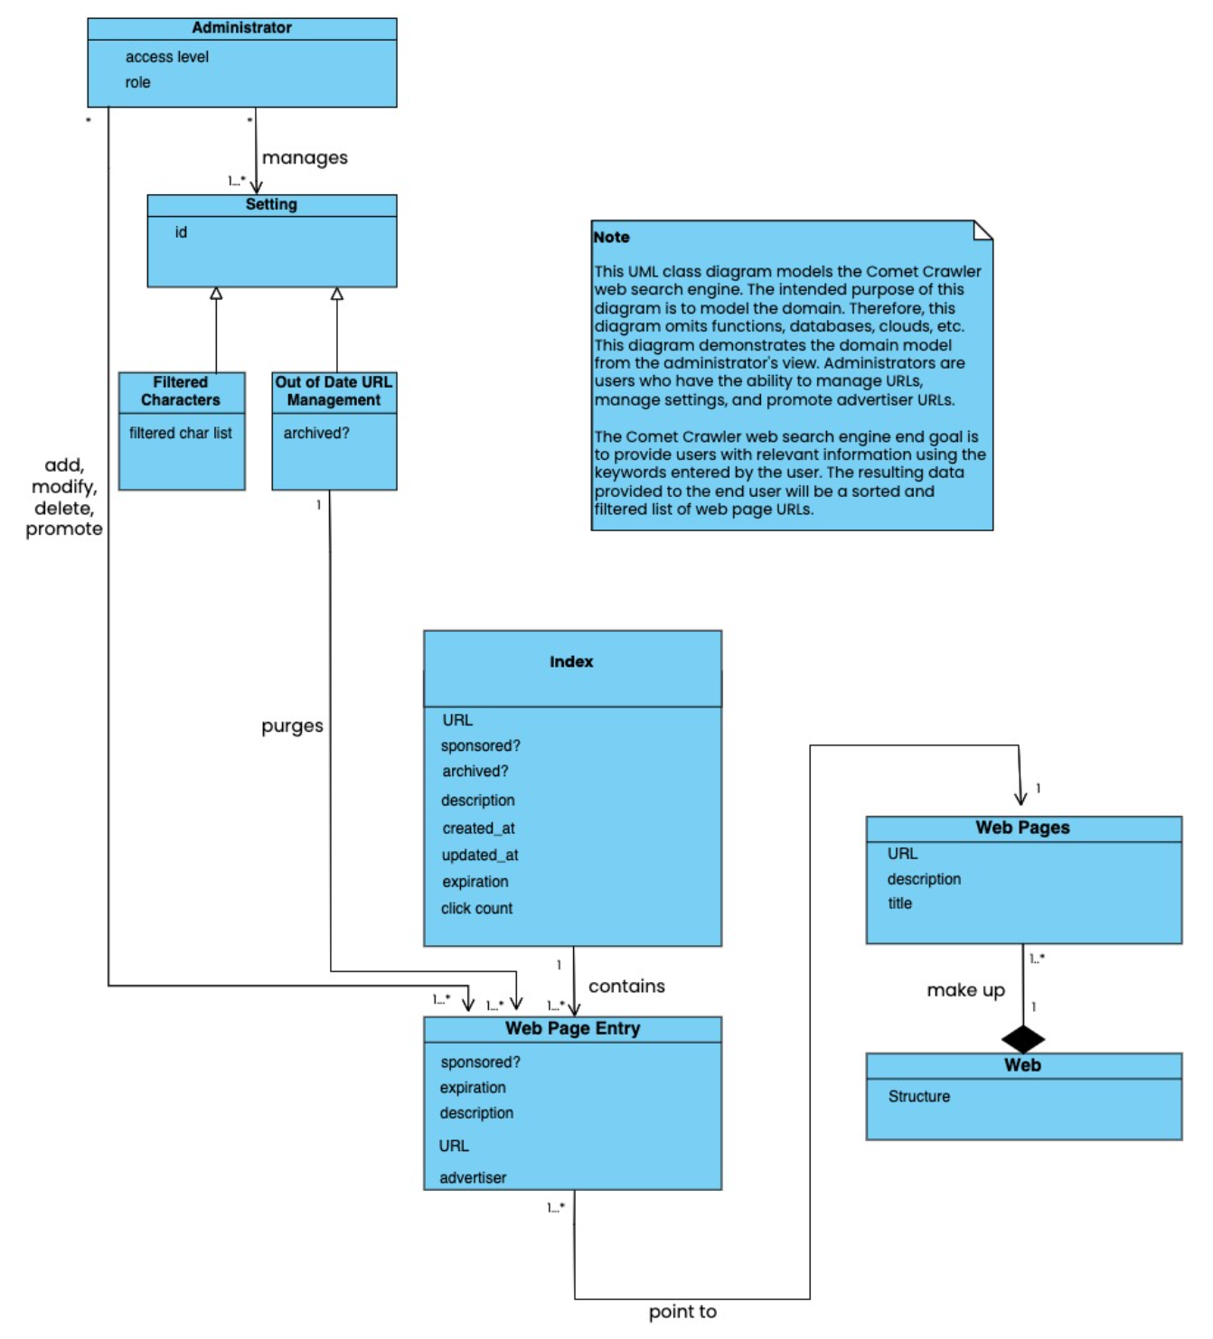

Figure 5.3 Comet Crawler Web Search Engine System Class Diagram (Based on Administrator’s View)

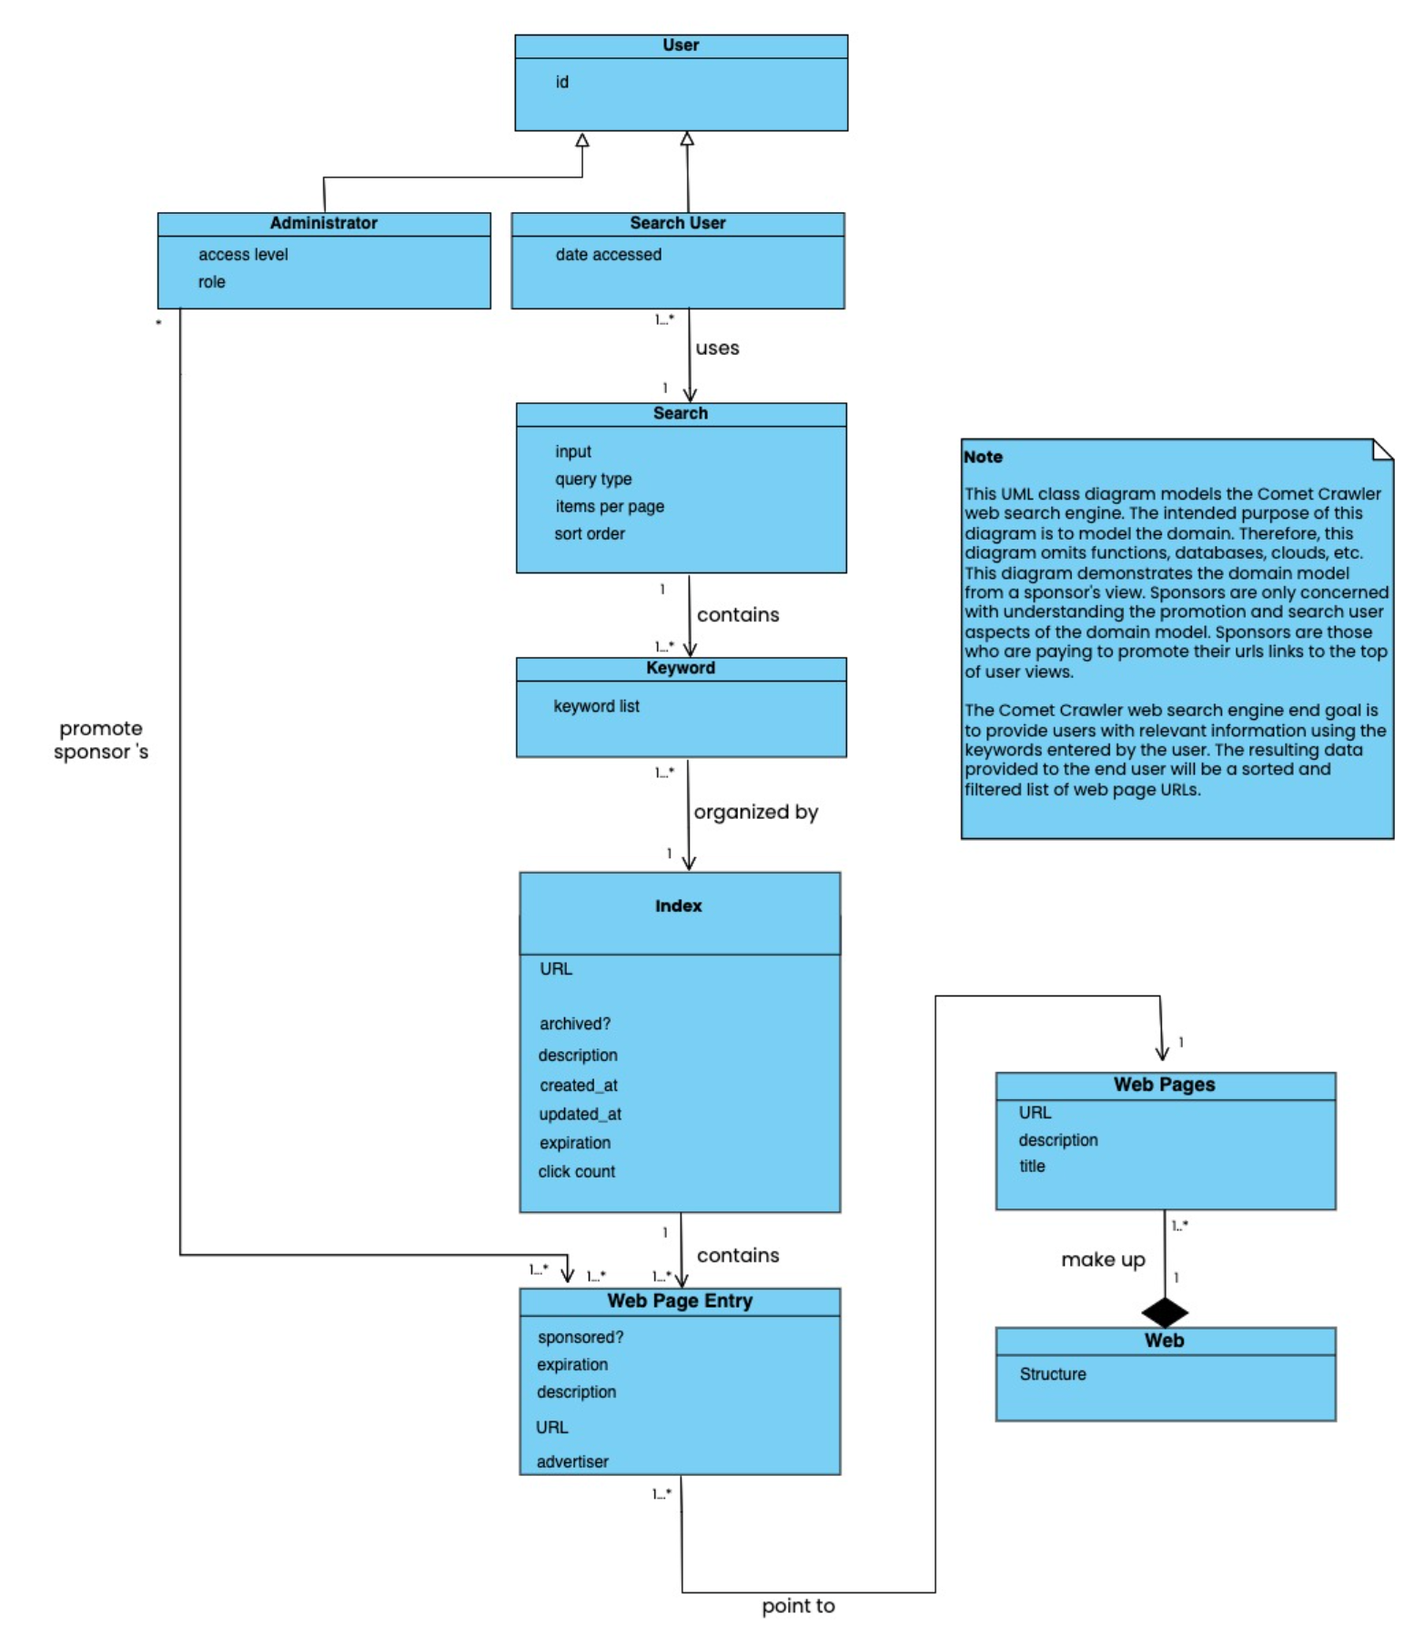

Figure 5.4 Comet Crawler Web Search Engine System Class Diagram (Based on Sponsor’s View)

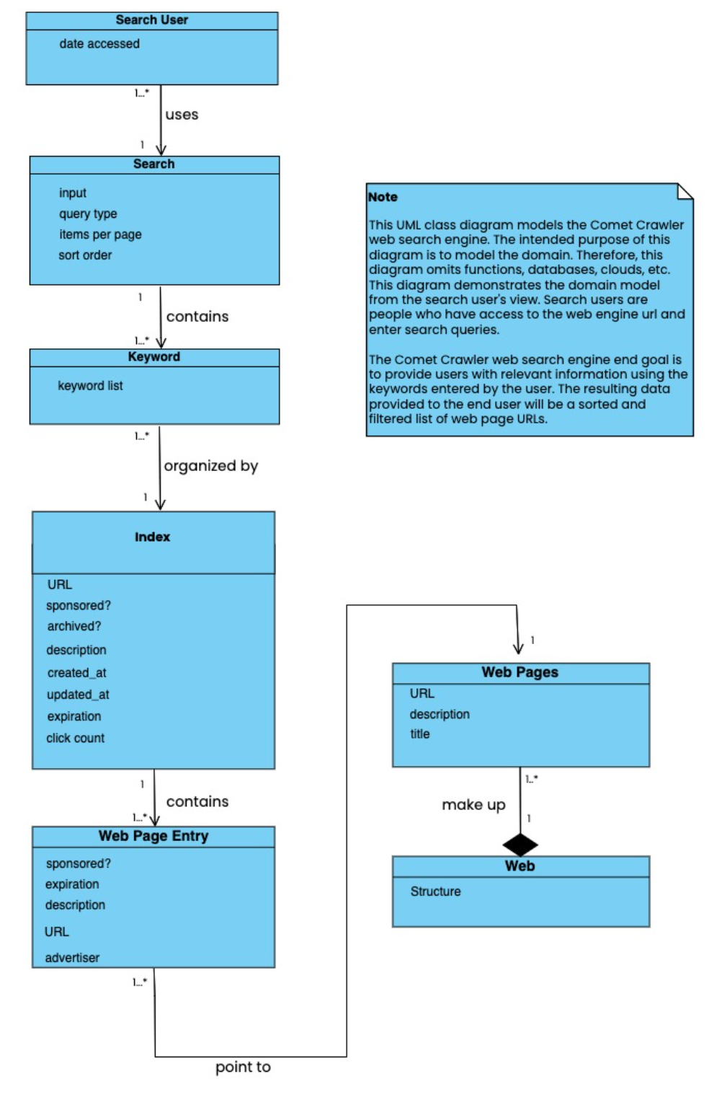

Figure 5.5 Comet Crawler Web Search Engine System Class Diagram (Based on Search User’s View)

**Design Class Diagrams:**

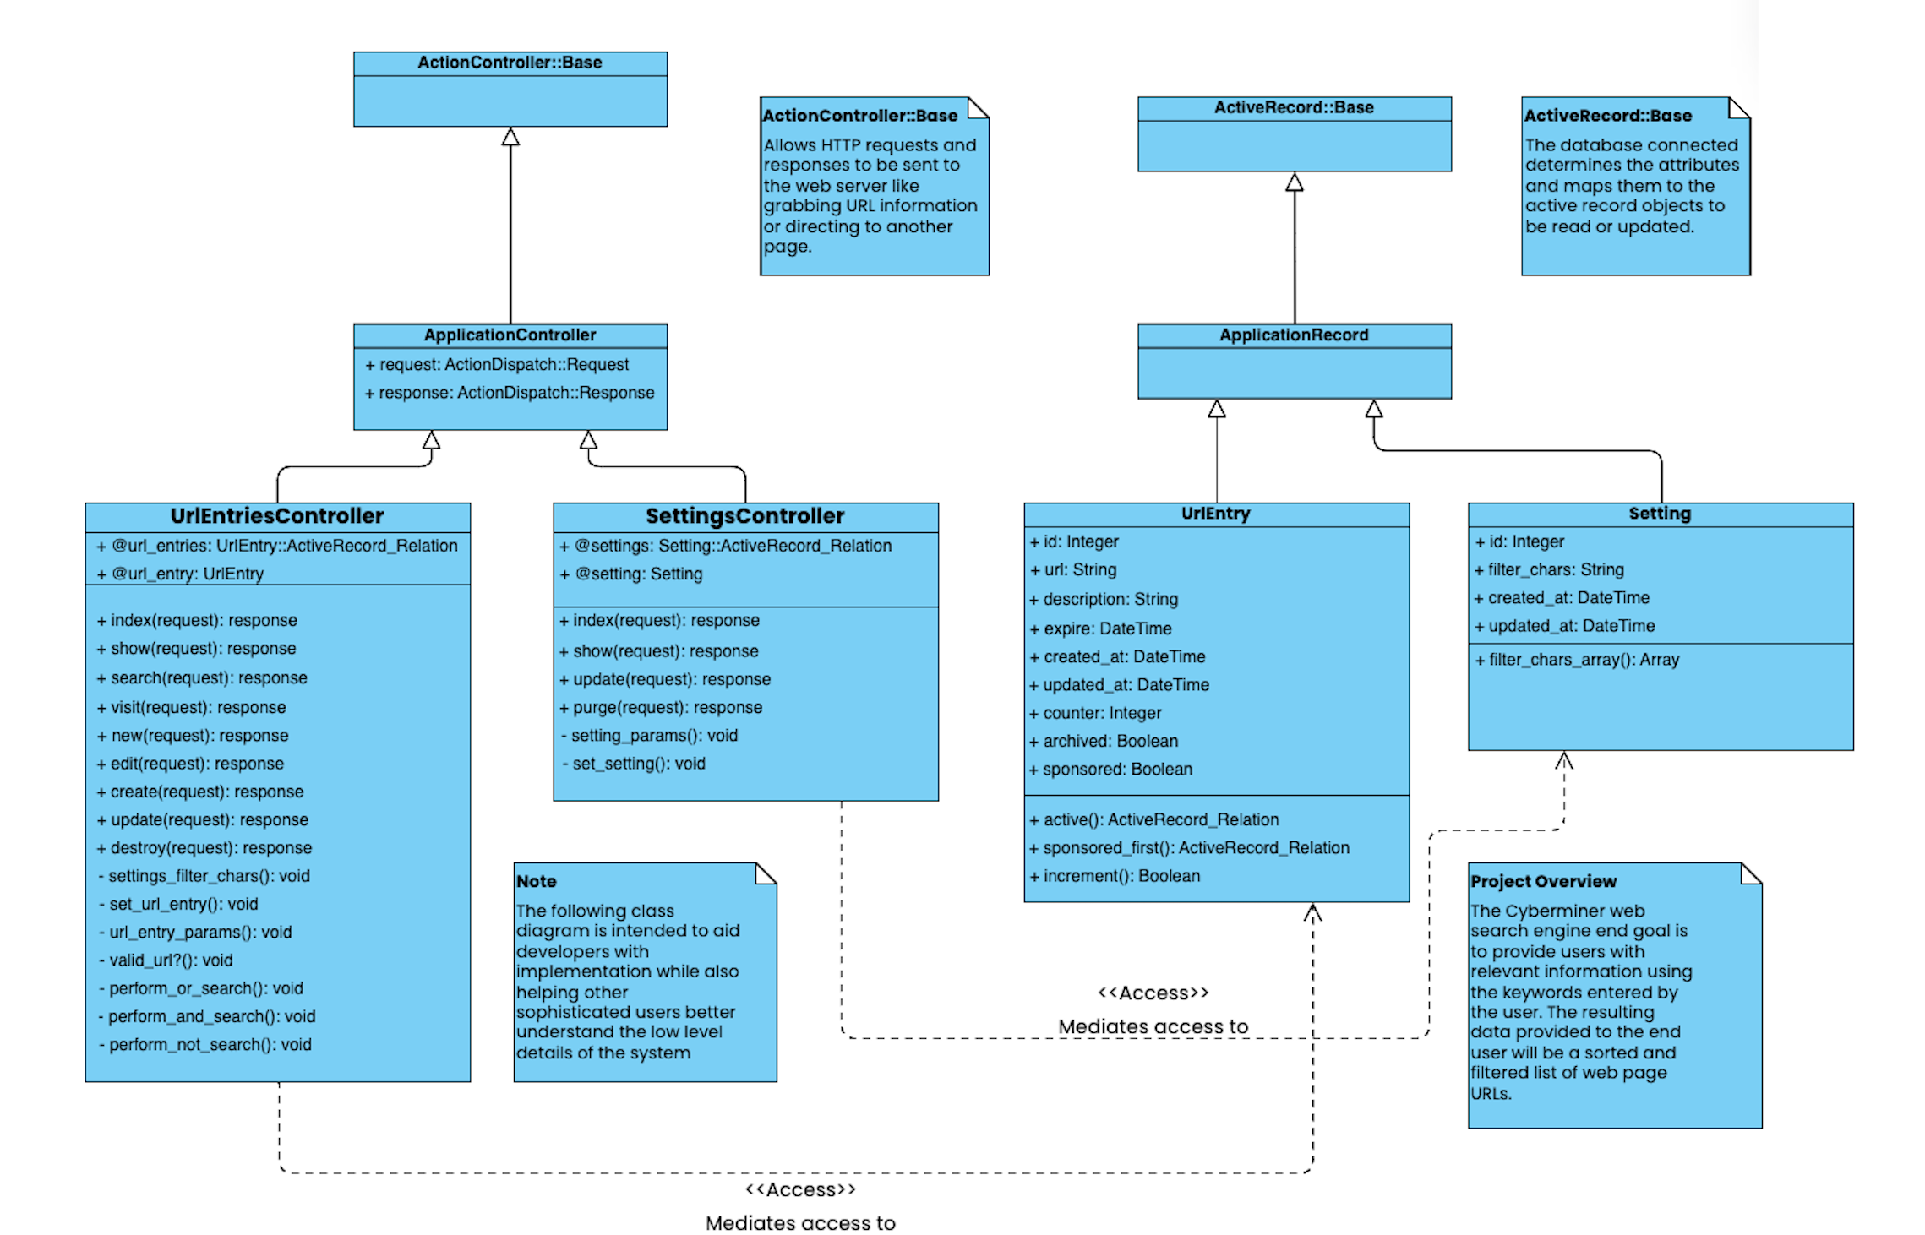

Figure 5.6 Comet Crawler Web Search Engine System’s Design Class Diagram

**6. Additional Points:**

**6.1 List of Additional Points and Links**

1. All our test cases can be found here: <https://github.com/tyharg/CS-4376/tree/main/test>
2. The Phase I User Manual can be found here: [User Manual](https://github.com/Areebah-Fatima/CS-4376.0U1/blob/main/Team%201%20User%20Manual%20(CS%204376.0U1).pdf)
3. The Preliminary Project Plan can be found here (outdated since it is from Phase I): [Preliminary Project Plan](https://github.com/Areebah-Fatima/CS-4376.0U1/blob/main/Final%20Submission%20Team%201%20Project%20Plan%20(CS%204376.0U1).pdf)